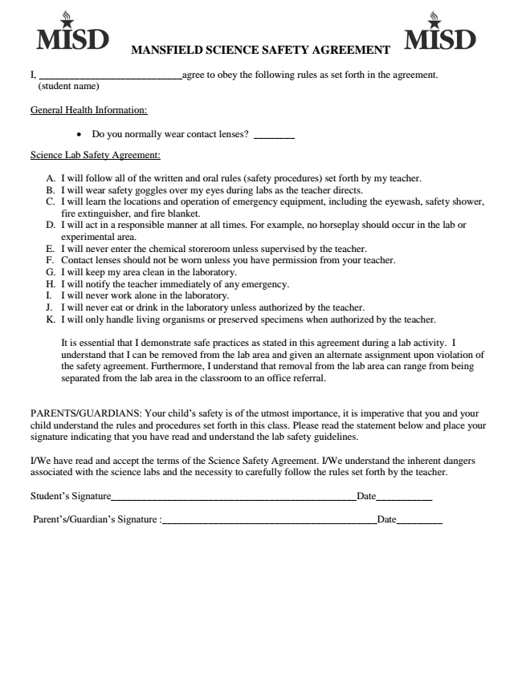
MANSFIELD SCIENCE SAFETY AGREEMENT

