Chemistry CBA Review
.

1. What is the most common element in the lithosphere?

2. Elements in the biosphere include:

3. Elements of the lithosphere include:

4. What is density?

5. If a substance has a mass of 63 grams and a volume of 7 mL, what is the density?

6. Mg is called an element’s what?

7. How many elements are represented in the following compound?
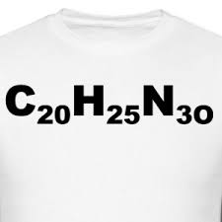

8. What is the most common element that the lithosphere and biosphere share?

9. Earth's atmosphere is made primarily of what element?

10. What is a compound?

11. If SpongeBob has a mass of 54 grams, what is his density?
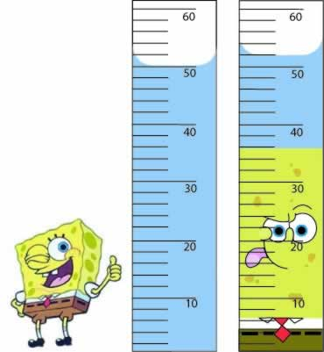

12. What is this an example of?
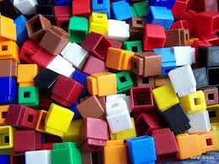

13. What is an element?

14. What are the signs of a chemical change?

15. What do all chemical changes have in common?

16. Given the following table, what would each element be classified?
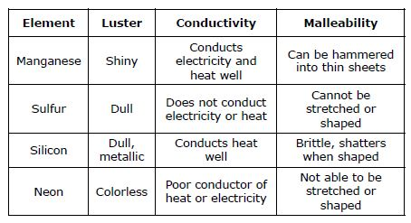
17. Create a table of the properties of metals, nonmetals, and metalloids using luster, malleability, and conductivity.

18. How many elements are represented in the following chemical reaction formula for photosynthesis?
C₆H₁₂O₆ + 6O₂ 6CO₂ + 6H₂O

19. Define metal, nonmetal, and metalloid.

20. Color metals blue, nonmetals red, and metalloids yellow.
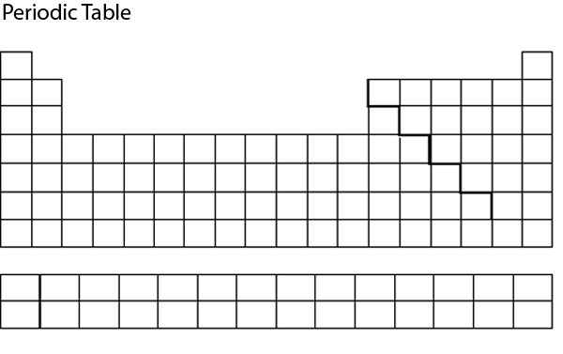

21. What is the hydrosphere and what elements make it up?

22. What is the atmosphere and what elements comprise it?

23. What is the biosphere and what elements comprise it?

Answers

- While many elements are present in the Earth’s lithosphere (Earth’s crust), oxygen is the most abundant. Here is the breakdown:
Oxygen (O) 47%
Silicon (Si) 28%
Aluminum (Al) 8%
Iron (Fe) 5%
Calcium (Ca) 3.6%
Other elements 8.6%
- Elements in the biosphere (all living matter) and the breakdown are:
Oxygen (O) 65%
Carbon ( C ) 18%
Hydrogen (H) 10%
Nitrogen (N) 3%
Other elements 4%
- Rocks are part of the Earth’s lithosphere, so silicon is the correct answer given the choices. See answer #1 for the list of elements.
- The formula for density is mass divided by volume, or mass/volume. Think of this picture and saying: If you don’t remember the formula for density, it’ll break your mother’s heart. 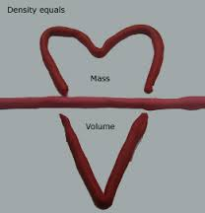 Or this picture 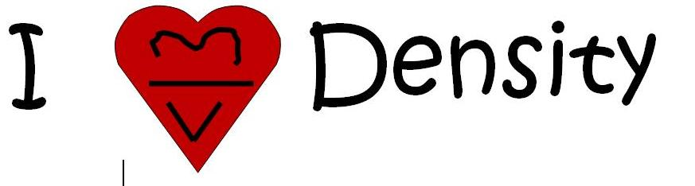

- Using the formula in answer 4, the density is 63 g/ 7 mL = 9 g/mL.

- Mg is a chemical symbol. Many want to say it is the name of an element, it’s not. It is a representation of the name. It represents an element, not a compound. The atomic number is just that, a number on the periodic table that tells the number of protons in the element.

- There are 3 elements represented here. An easy trick is to count the number of capital letters—at this point names do not have to be memorized. Remember, lower case do not count.

- The most common element found in the lithosphere and biosphere is oxygen. See answers 1 and 2 for the element breakdown.

- Against common belief, the atmosphere’s most common element is not oxygen, but in fact, nitrogen. Here is the breakdown!
Nitrogen (N) 78%
Oxygen (O) 21%
Other elements 1%

- Compounds are more than one type of matter--for example, salt is NaCl—2 different elements.
- This is demonstrating water displacement. In the first cylinder, there is an initial volume of 50 mL of water. When Spongebob is added, the water level rises to 52 ml (watch your units!!) So, you must subtract the initial water volume from the final volume to get the volume of Spongebob, so 52 mL – 50 mL = 2 mL as Spongebob’s volume. To find density, remember that it is mass/volume, so you must now plug in what you know and divide. 54g (given)/2mL = 27 g/mL.
- This is a mixture. All the blocks are different, and they are not all joined creating a compound. I can physically separate the blocks into piles without having to “pull” them apart—or break the chemical bond.
- An element is a pure substance that cannot be broken down into simpler substances. If I were to break down an element, I would be looking at the pieces of an atom.

